Lab 2: The ID Pipeline Stage

George Suarez and Patrick Duggin

October 31, 2018

# Introduction

The objective of this lab is to implement and test the Instruction Decode (ID) pipeline stage and integrate it with the IF stage. There are five modules to implement which are: I_DECODE, CONTROL, REG, S_EXTEND, and ID_EX.

# Interface

The CONTROL module receives the 6-bits of instruction code from the opcode field of IF_ID_instr and divides it into EX, M, and WB control lines.

Table 1: control Inputs

|  |  |
| --- | --- |
| Name | Function |
| opcode | The 6-bits from the opcode field of IF_ID_instr |

Table 2: control Outputs

|  |  |
| --- | --- |
| Name | Function |
| EX | The 4-control bit |
| M | The 3-control bit |
| WB | The 2-control bit |

The REGISTER module fills 32-bit registers/addresses with zero where a reg_write control line specifies a 1 for writing data and a 0 for not writing data. This module outputs two 32-bit registers where one of them holds the contents for the source registers and the contents for the target registers.

Table 3: register Inputs

|  |  |
| --- | --- |
| Name | Function |
| rs | The 5-bit source register |
| rt | The 5-bit target register |
| rd | The 5-bit destination register |
| write_data | The 32-bit data |
| reg_write | The 1-bit that toggles between 1 or 0 |

Table 4: register Outputs

|  |  |
| --- | --- |
| Name | Function |
| A | The 32-bit register that holds the result of REG[rs] |
| B | The 32-bit register that holds the result of REG[rd] |

The combinational module S_EXTEND extends a 16-bit number into a 32-bit number and controls if the number is a positive or negative.

Table 5: s_extend Inputs

|  |  |
| --- | --- |
| Name | Function |
| Next_end | The 16-bit immediate field of IF_ID_instr |

Table 6: s_extend Outputs

|  |  |
| --- | --- |
| Name | Function |
| extend | The 32-bit sign-extended value |

The ID_EX module is the pipeline register that inputs and outputs the program counter and instruction.

Table 7: id_ex Inputs

|  |  |
| --- | --- |
| Name | Function |
| ctlwb_out | The 2-control bit for write back (WB) |
| ctlm_out | The 3-control bit for memory (M) |
| ctlex_out | The 4-control bit for execute (EX) |
| npc | The 32-bit new program counter |
| readdata1 | The 32-bit data from REG[rs] |
| readdata2 | The 32-bit data from REG[rt] |
| signext_out | The 32-bit value from s_extend |
| instr_2016 | The 5-bit instruction code from instr[20:16] |
| instr_1511 | The 5-bit instruction code from instr[15:11] |

Table 8: id_ex Outputs

|  |  |
| --- | --- |
| Name | Function |
| wb_ctlout | The 2-bit register that holds the result from ctlwb_out |
| wb_ctlm | The 3-bit register that holds the result from ctlm_out |
| wb_ctlex | The 4-bit register that holds the result from ctlex_out |
| regdst | The 1-bit register that holds the result of ctlex_out[3] |
| alusrc | The 1-bit register that holds the result of ctlex_out[0] |
| npcout | The 32-bit register that holds the result of npcout |
| rdata1out | The 32-bit register that holds the result of readdata1 |
| rdata2out | The 32-bit register that holds the result of readdata2 |
| s_extendout | The 32-bit register that holds the result of signext_out |
| instrout_2016 | The 5-bit register that holds the result of instr_2016 |
| instrout_1511 | The 5-bit register that holds the result of instr_1511 |

# Design

The design of the CONTROL module takes in a 6-bit opcode that outputs the control bits for WB, M, and EX.

Figure 1: Control design

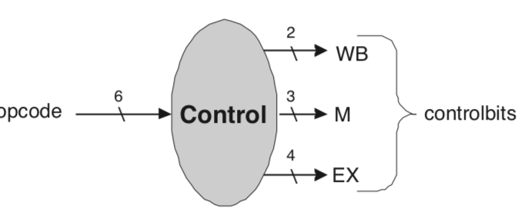

The design of the REG module takes in a 5-bit source register, a 5-bit target register, a 5-bit destination register, and a 32-bit data register that holds the data. Then it outputs two 32-bit registers that holds the contents of the source and target registers respectively.

Figure 2: REG design

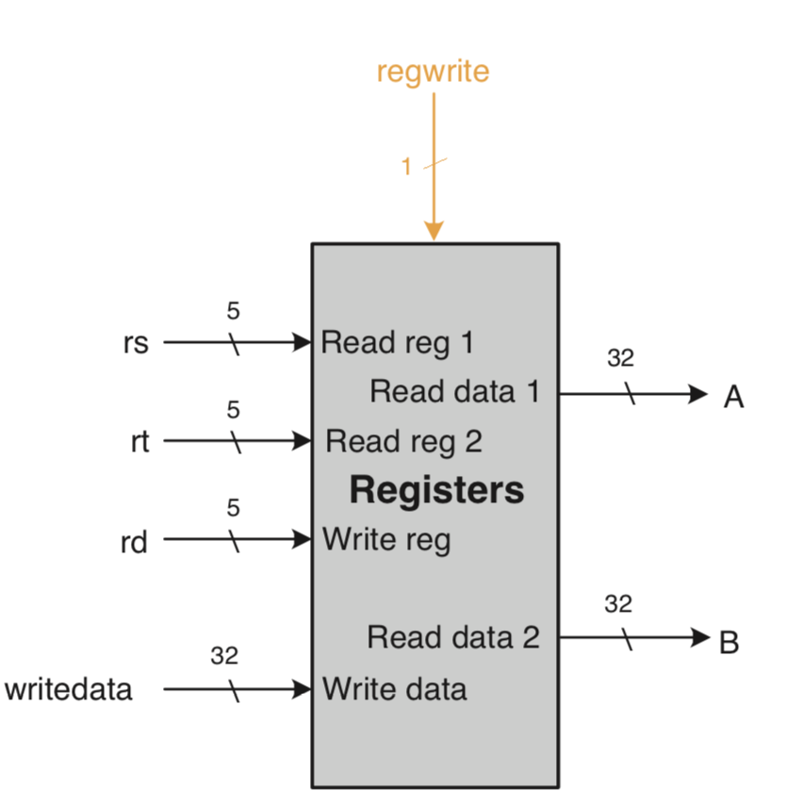

The design of the S_EXTEND module takes in a 16-bit number and outputs the 32-bit version of that 16-bit number. Also maintains the characteristics of the number whether it is a positive or negative.

Figure 3: S_EXTEND design

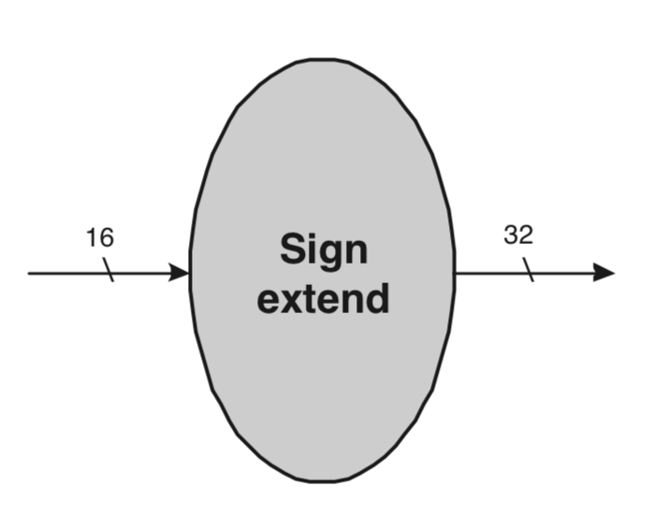

The design for the ID_EX memory module has 9 control bits that is divided into 3 control wires that handles the write back, memory, and execution. It takes in a 32-bit NPC, two 32-bit read data registers, 32-bit sign extender, and two 5-bit instruction code registers. Then it outputs the program counter and instructions.

Figure 4: ID_EX module design

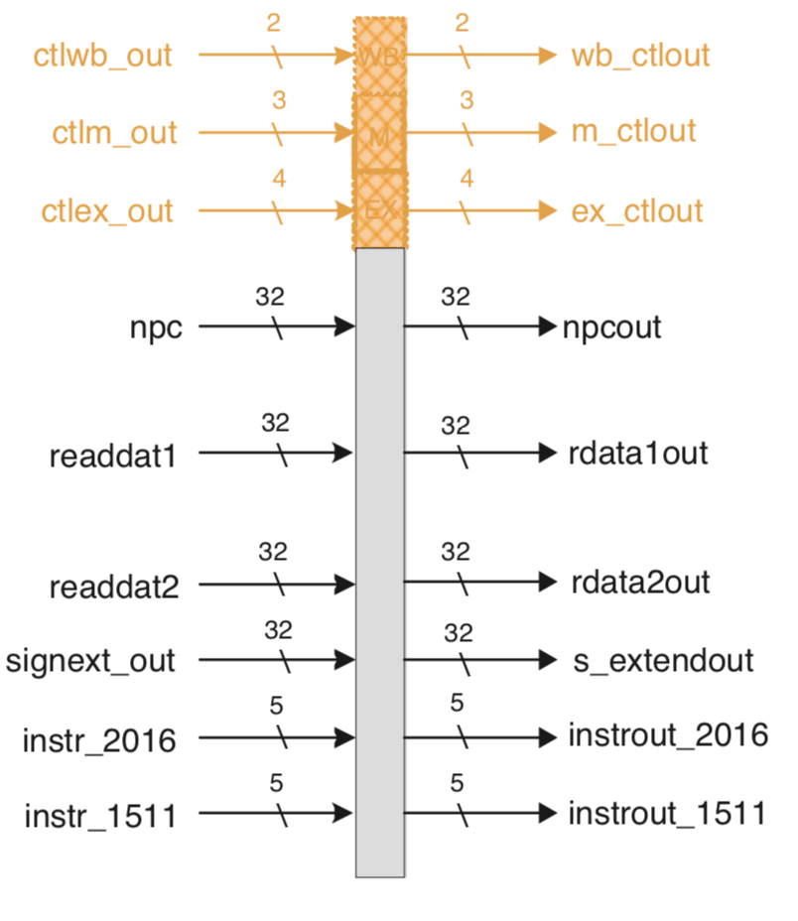

# Implementation

Listing 1: Implementation for control

|  |
| --- |
| `timescale 1ns / 1ps  module control (  input wire [5:0] opcode,  output reg [3:0] EX,  output reg [2:0] M,  output reg [1:0] WB  );    parameter RTYPE = 6'b000000;  parameter LW = 6'b100011;  parameter SW = 6'b101011;  parameter BEQ = 6'b000100;  parameter NOP = 6'b100000;    initial begin  /* Assign decimal representation of 0 to our output  REG's here. Note the difference  */  EX <= 0;  M <= 0;  WB <= 0;  end    /* Assign the don't cares (X) to high impedance (Z)...  For design correctness and more proper MIPS emulation  */    always @ * begin  case (opcode)  RTYPE: begin  EX <= 4'b1100; /* Note use of non-blocking operator (<=) vs blocking operator (=) */  M <= 3'b000;  WB <= 2'b10;  end  /* Assign the remaining values according to the chart in Lab Manuel.  Either parametrize it, or hardcode at as is done for RTYPE.  */  LW: begin  EX <= 4'b0001;  M <= 3'b010;  WB <= 2'b11;  end    SW: begin  EX <= 4'b0001;  M <= 3'bz01;  WB <= 2'b0z;  end    BEQ: begin  EX <= 4'bz010;  M <= 3'b100;  WB <= 2'b0z;  end    NOP: begin  EX <= 4'b0000;  M <= 3'b000;  WB <= 2'b00;  end    default: $display ("Opcode not recognized.");  endcase  end  endmodule // control |

Listing 2: Implementation for register

|  |
| --- |
| `timescale 1ns / 1ps  module register (  input [4:0] rs,  input [4:0] rt,  input [4:0] rd,  input [31:0] write_data,  input reg_write,  output reg [31:0] A, // rs output  output reg [31:0] B // rd output  );    // Register declaration  reg [31:0] REG [0:31]; // Gives us 32 registers, each 32 bits long    integer i;    initial begin  A <= 0;  B <= 0;    // Initialize our registers  for (i = 0; i < 32; i = i + 1)  REG[i] <= 0;    // Display contents of the first 9 registers  $display("From Register Memory:");  for (i = 0; i < 9; i = i + 1)  $display("\tREG[%0d] = %0d", i, REG[i]);    // Display last register  $display("\t...");  $display("\tREG[%0d] = %0d", 31, REG[31]);  end    always @ * begin  A <= REG[rs];  B <= REG[rt];    // Write data using index rd  if (rd != 0 && reg_write)  REG[rd] <= write_data;  end    endmodule // register |

Listing 3: Implementation for s_extend

|  |
| --- |
| `timescale 1ns / 1ps  module s_extend(  input wire [15:0] next_end,  output reg [31:0] extend  );    always @ * begin  // Replicate signed bit 16 times then cancatinate  extend = { {16{next_end[15]}}, next_end };  end    endmodule // s_extend |

Listing 4: Implementation for id_ex

|  |
| --- |
| `timescale 1ns / 1ps  module id_ex(  input wire [1:0] ctlwb_out,  input wire [2:0] ctlm_out,  input wire [3:0] ctlex_out,  input wire [31:0] npc, readdata1, readdata2, signext_out,  input wire [4:0] instr_2016, instr_1511,  output reg [1:0] wb_ctlout,  output reg [2:0] m_ctlout,  output reg regdst, alusrc,  output reg [1:0] aluop,  output reg [31:0] npcout, rdata1out, rdata2out, s_extendout,  output reg [4:0] instrout_2016, instrout_1511  );    initial begin  // Assign 0's to everything  wb_ctlout <= 0;  m_ctlout <= 0;  regdst <= 0;  aluop <= 0;  alusrc <= 0;  npcout <= 0;  rdata1out <= 0;  rdata2out <= 0;  s_extendout <= 0;  instrout_2016 <= 0;  instrout_1511<= 0;  end  always @ * begin  // Wire the inputs to the outputs corresponding outputs  #1  wb_ctlout <= ctlwb_out;  m_ctlout <= ctlm_out;  regdst <= ctlex_out[3];  aluop <= ctlex_out[2:1];  alusrc <= ctlex_out[0];  npcout <= npc;  rdata1out <= readdata1;  rdata2out <= readdata2;  s_extendout <= signext_out;  instrout_2016 <= instr_2016;  instrout_1511 <= instr_1511;  end  endmodule // id_ex |
|  |

Listing 5: Implementation for the top-level I_DECODE module

|  |
| --- |
| `timescale 1ns / 1ps    module I_DECODE(      input wire [31:0] IF_ID_instrout,     input wire [31:0] IF_ID_npcout,      input wire [4:0]  MEM_WB_rd,      input wire MEM_WB_regwrite,      input wire [31:0] WB_mux5_writedata,      output wire [1:0] wb_ctlout,      output wire [2:0] m_ctlout,      output wire regdst, alusrc,      output wire [1:0] aluop,      output wire [31:0] npcout, rdata1out, rdata2out, s_extendout,      output wire [4:0] instrout_2016, instrout_1511     );  *// Signals*      wire [3:0] ctlex_out;      wire [2:0] ctlm_out;      wire [1:0] ctlwb_out;      wire [31:0] readdata1, readdata2, signext_out;    *// instantiations*      control control2(          .opcode( IF_ID_instrout[31:26] ), *// input*          .EX( ctlex_out ),         *// outputs*          .M( ctlm_out ),          .WB( ctlwb_out )        );        register register2(          .rs( IF_ID_instrout[25:21] ), *// inputs*          .rt( IF_ID_instrout[20:16] ),          .rd( MEM_WB_rd ),          .writedata( WB_mux5_writedata ),          .regwrite( MEM_WB_regwrite ),          .A(readdata1),           *//outputs*          .B(readdata2)        );        s_extend s_extend2(          .nextend( IF_ID_instrout[15:0] ),          .extend( signext_out )        );        id_ex id_ex2(          .ctlwb_out( ctlwb_out ),  *// 9 inputs*          .ctlm_out( ctlm_out ),          .ctlex_out( ctlex_out ),          .npc( IF_ID_npcout ),          .readdat1( readdata1 ),          .readdat2( readdata2 ),          .signext_out( signext_out ),          .instr_2016( IF_ID_instrout[20:16] ),          .instr_1511( IF_ID_instrout[15:11] ),          .wb_ctlout( wb_ctlout ),  *// outputs*          .m_ctlout( m_ctlout ),          .regdst( regdst ),          .alusrc( alusrc ),          .aluop( aluop ),          .npcout( npcout ),          .rdata1out( rdata1out ),          .rdata2out( rdata2out ),          .s_extendout( s_extendout ),          .instrout_2016( instrout_2016 ),          .instrout_1511( instrout_1511 )        );    endmodule *// I_DECODE* |

# Test Bench Design

The CONTROL test bench is designed to display the 6-bit opcode from the instructions code register and output what control bits are being used from the given instructions. Some opcodes should not be recognized if the control bits do not match any of the instructions code (see Listing 6 for the Verilog code).

The REG test bench is designed to assign source, target, and destination registers with random data with toggling the reg_write wire to either 1 for writing data or 0 for not writing data. Then the timing diagram will show a 5*ns* simulation that shows the contents of the registers (see Listing 7 for the Verilog code).

The S_EXTEND test bench is designed to display two 16-bit numbers with one having 1 has the most significant bit and the other having 1 as the least significant bit. Then it displays the extended 32-bit version of those two numbers (see Listing 8 for the Verilog code).

Listing 6: Control Test Bench

|  |  |
| --- | --- |
| module test ();  // Port wires  wire [08:0] controls;    // Register Declarations  reg [31:0] instr;    initial begin  instr[31:26] <= 6'b0;  $display("Time\t\tOPCODE\t\t\t\t\Controlbits\n");  $monitor("%0d\t\t%b\t%b ", $time, instr, controls);  #20; $finish;  end    always begin  #1 instr[31:26] = 35;  #1 instr[31:26] = 43;  #1 instr[31:26] = 4;  #1 instr[31:26] = 100;  #1 instr[31:26] = 0;  end    control control1 ( instr[31:26], controls );  endmodule    Listing 7: Register Test Bench   |  | | --- | | `timescale 1ns / 1ps  module test;    // Outputs  wire [31:0] A, B;    // Inputs  reg [4:0] rs, rt, rd;  reg [31:0] write_data;  reg reg_write;    register uut( .rs( rs ),  .rt( rt ),  .rd( rd ),  .write_data( write_data ),  .reg_write( reg_write ),  .A( A ),  .B( B ) );    initial  begin  rs = 0;  rt = 1;  reg_write = 0;    #1  rs = 2;  rt = 3;  rd = 3;  write_data = 100;    #1  rs = 4;  rt = 5;  reg_write = 1;    #1  reg_write = 0;  rt = 3;    #1  rs = 6;  reg_write = 1;  rd = 6;  write_data = 100;    #1 $finish;  end  endmodule | |

Listing 8: Sign Extend Test Bench

|  |
| --- |
| module test();  *// Port Wires*  wire [31:0] se_out;    *// Register Declarations*  reg [15:0] se_in;    initial begin  se_in = 0;  #1 se_in = 16'b10;  #1 se_in = 16'b01;  end    initial begin  $monitor("Time = %0d\tse_in = %b\tse_out = %b", $time, se_in, se_out);  end    s_extend s_extend1( .next_end( se_in ), .extend( se_out ) );    endmodule |

# Simulation

Figure 5: Control test results from Listing 6



Figure 6: Register Timing diagram from 0ns – 5ns



Figure 7: Sign extend test results from Listing 8



# Conclusions

The instruction decode stage for this lab was successfully implemented. The main thing we learned in doing this lab is how to run individual test benches in Vivado, and how to connect the instruction fetch stage with the instruction decode stage together. What we would have done differently in this lab is to implement a module, and then test that module before starting on the next module.